Project – 3
Repo URL - https://github.com/sriram-R-krishnan/devops-build - Mapped
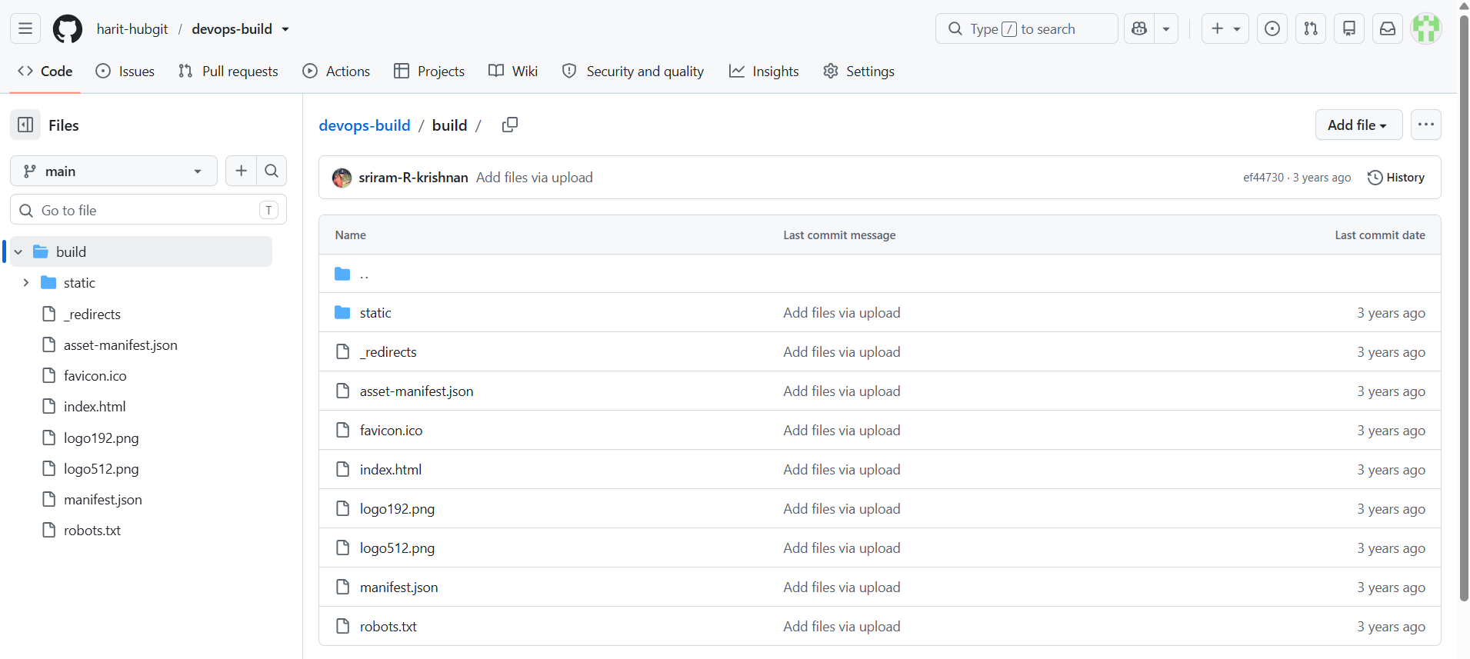


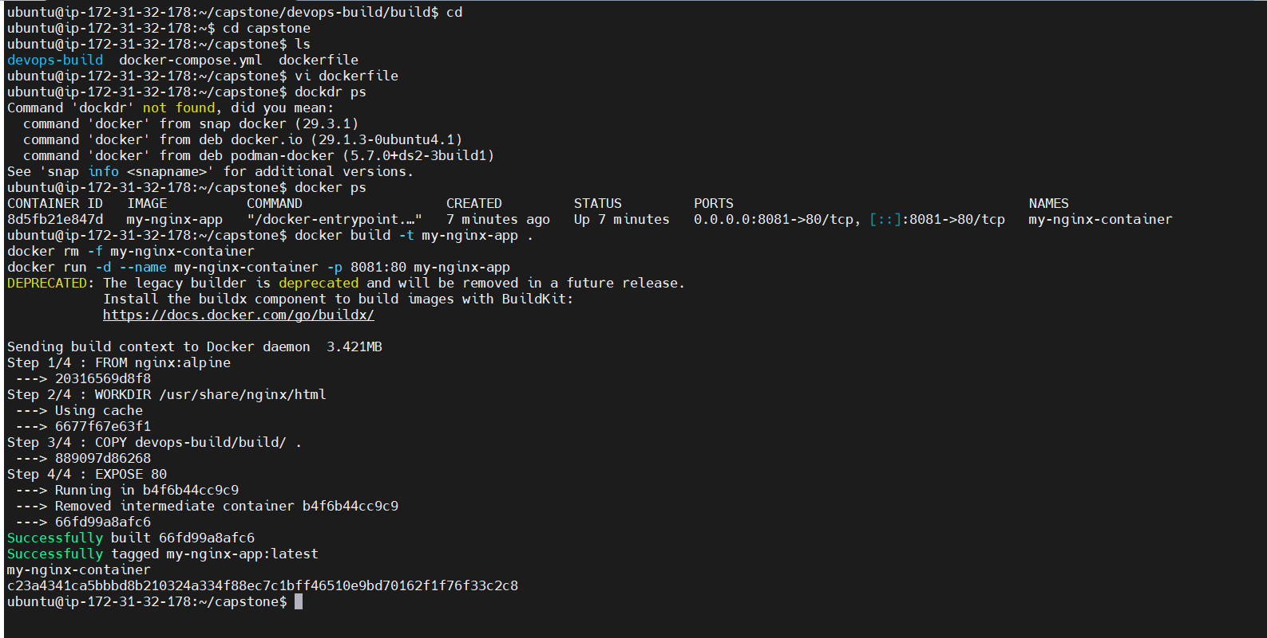
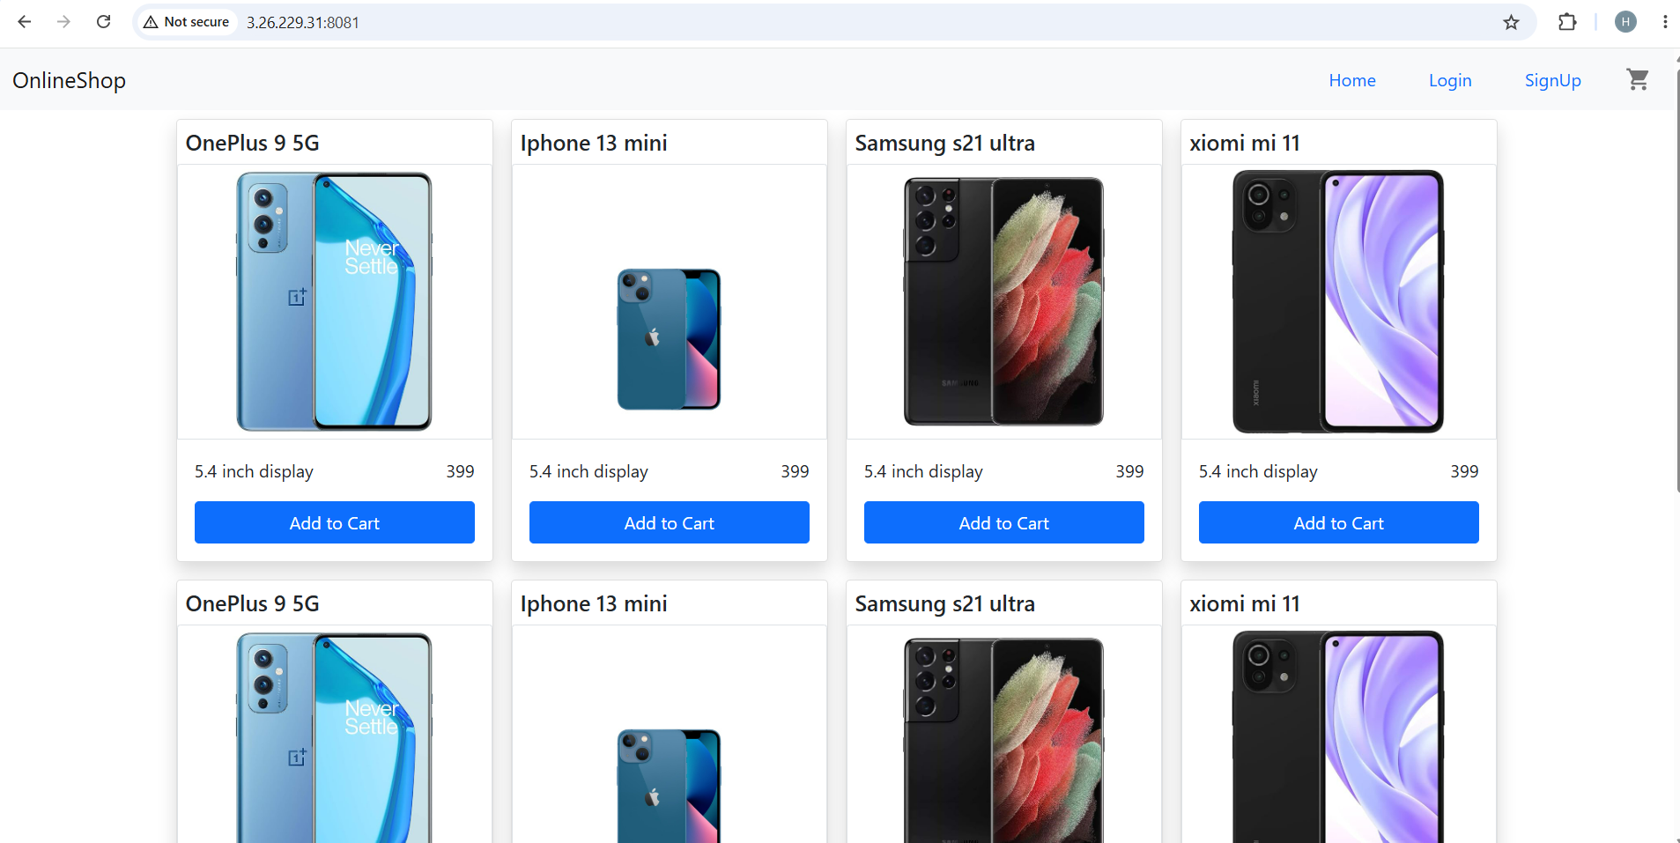

Bash Scripting
Write 2 scripts
Build.sh – for building docker images
Deploy.sh – for deploying the image to server
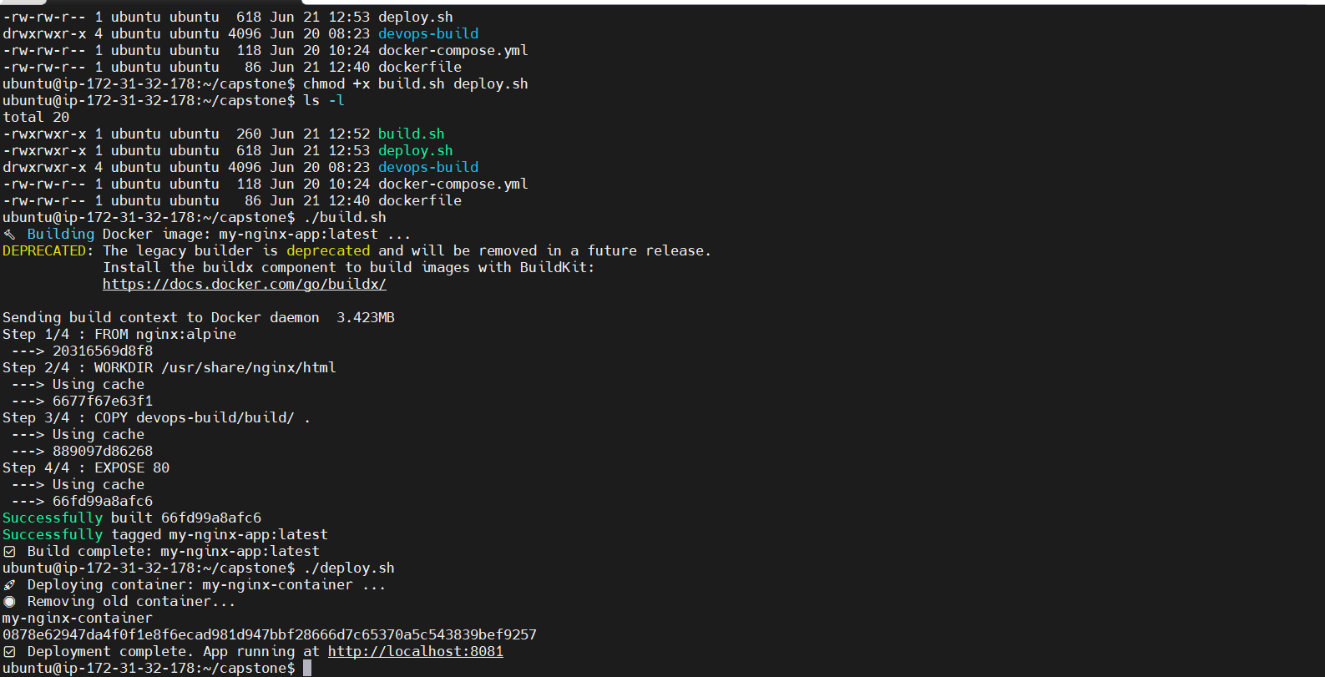
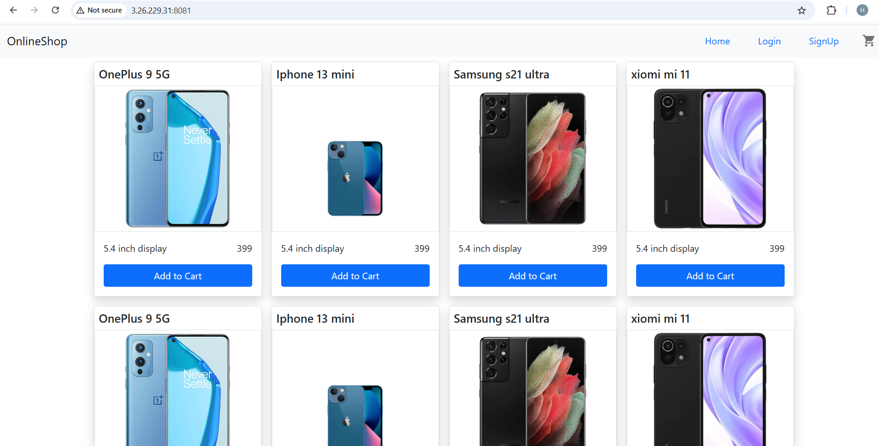

Version Control
- Push the code to GitHub into the dev branch
- Use .dockerignore and .gitignore files
- Note: Use only CLI for Git commands
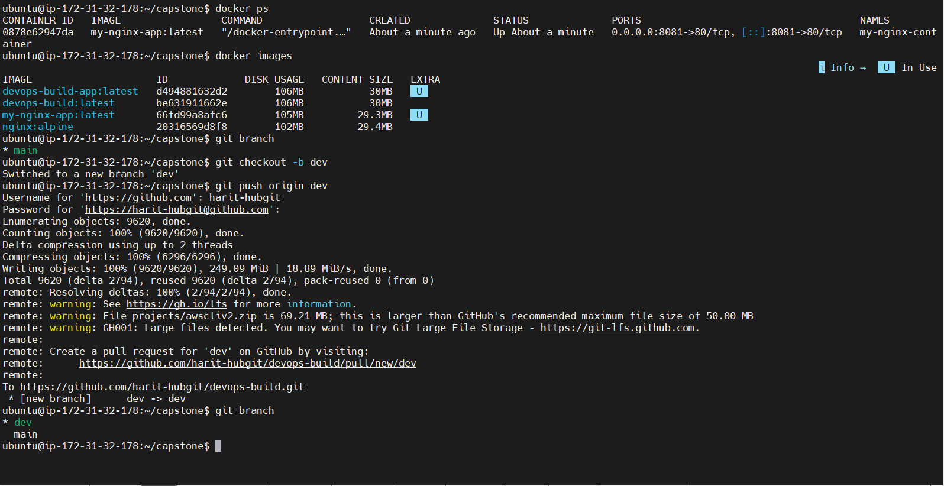
Docker Hub
- Create two repositories: dev and prod
- prod repo must be private
- dev repo can be public
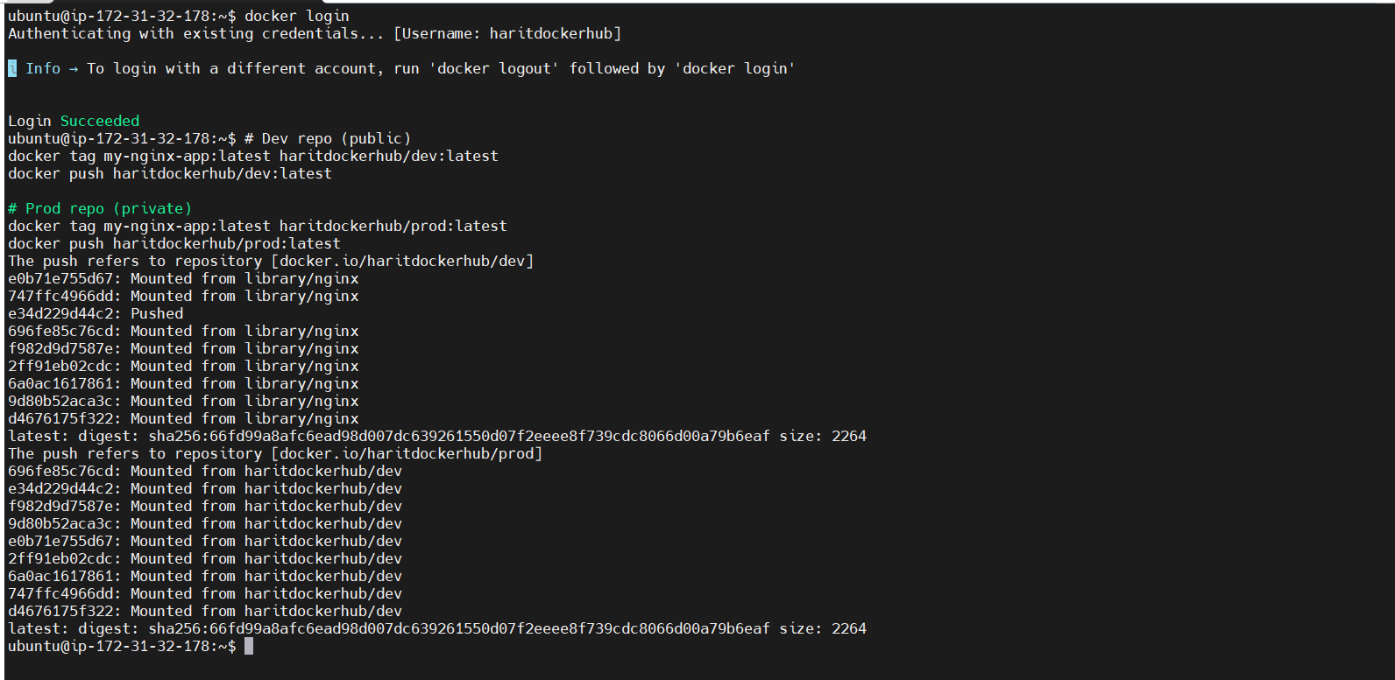
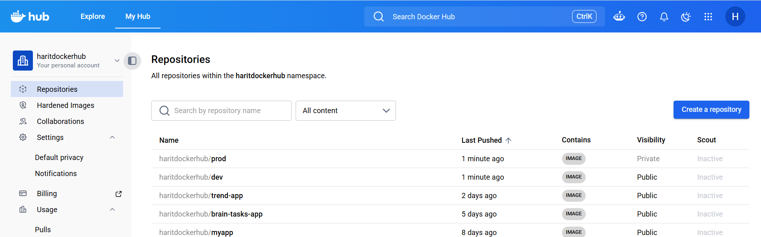

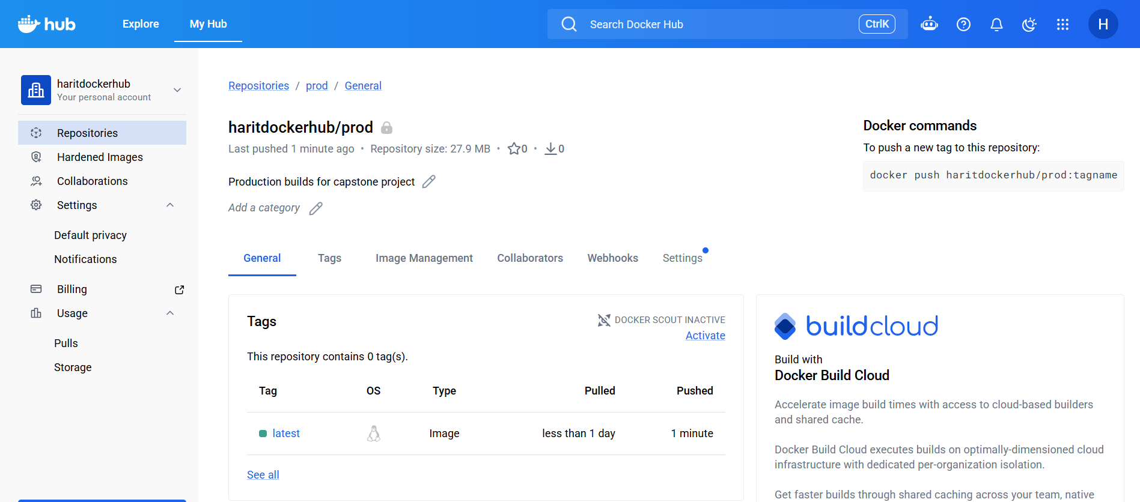
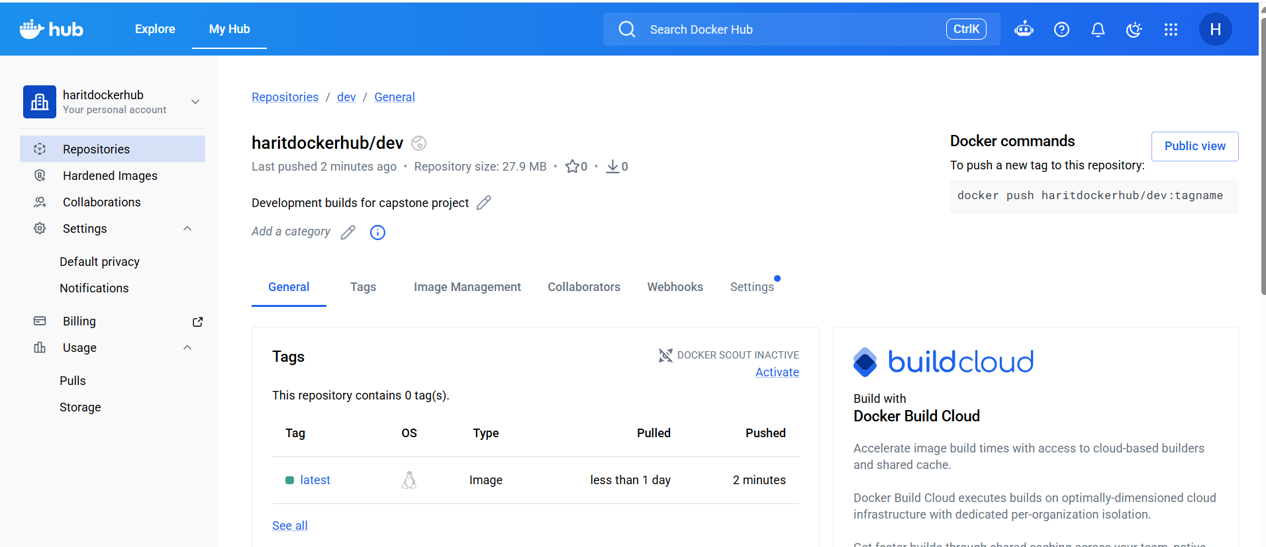

Jenkins
- Install and configure Jenkins build steps as needed to build, push, and deploy the application
- Connect Jenkins to the GitHub repo with auto-build triggers from both dev and master branches
- If code is pushed to dev branch → Docker image must be built and pushed to dev repo in Docker Hub
- If dev is merged into master → Docker image must be pushed to prod repo in Docker Hub
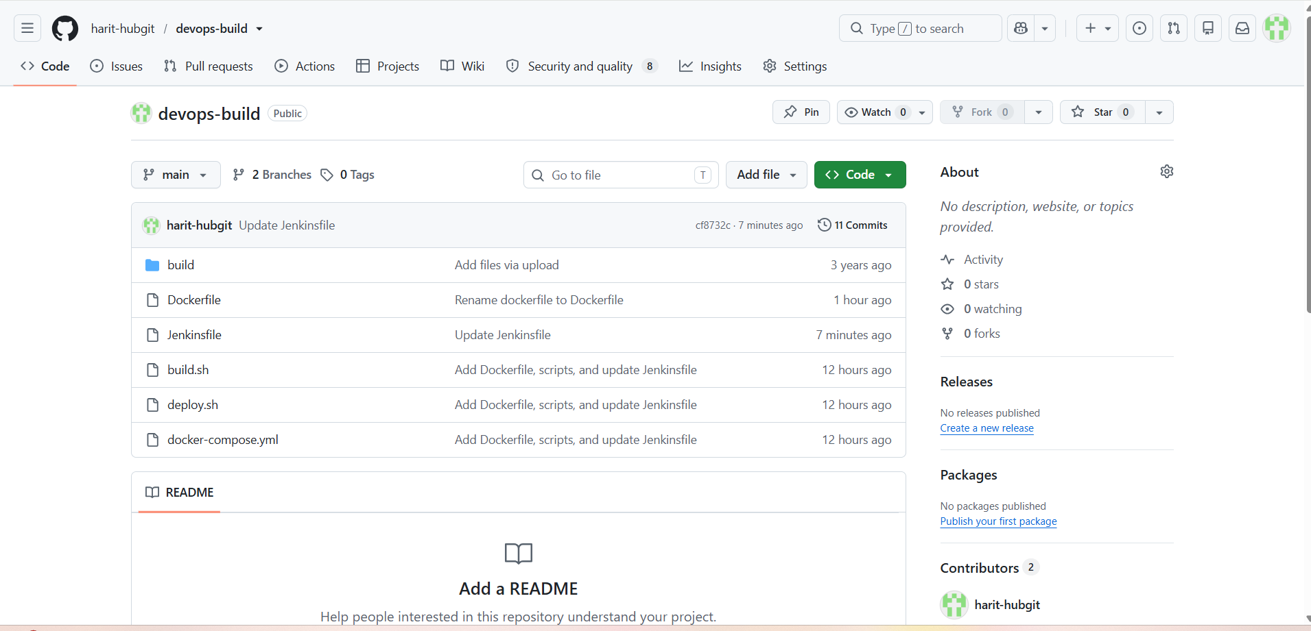

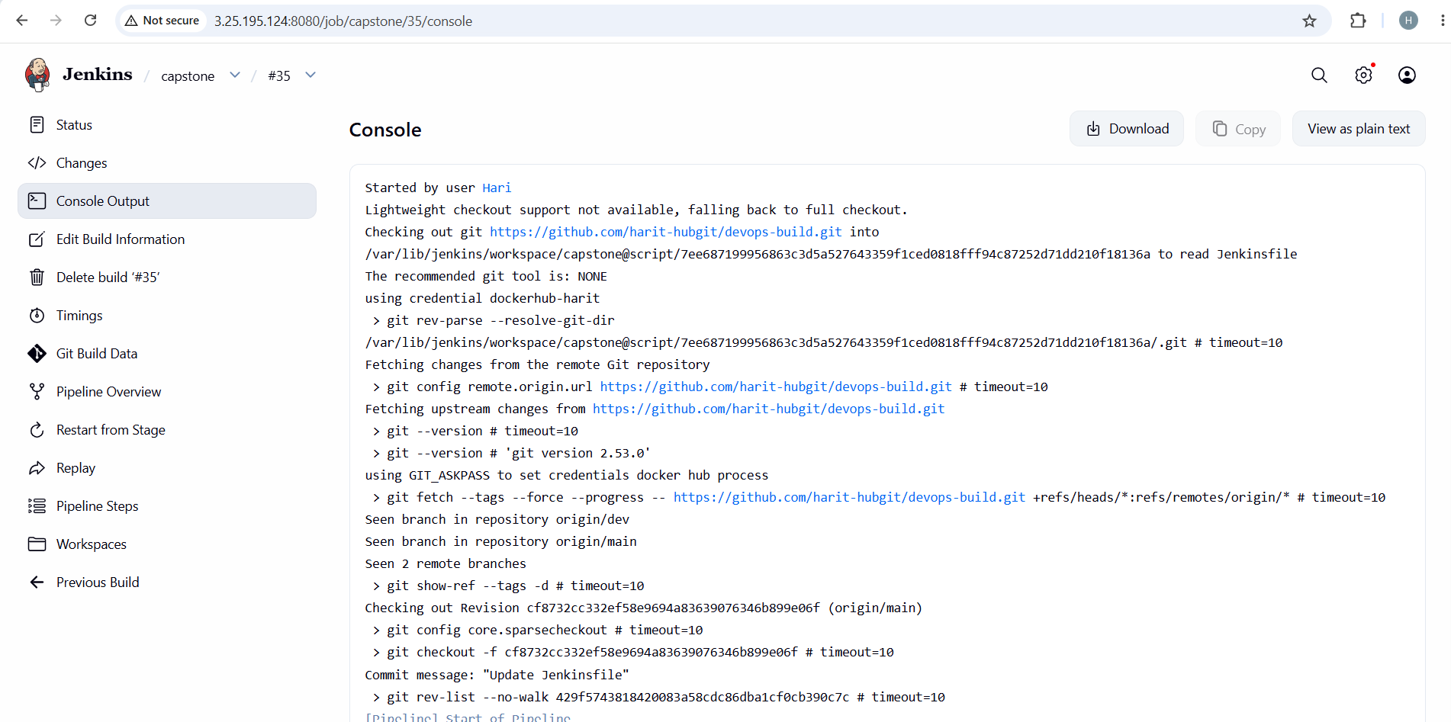
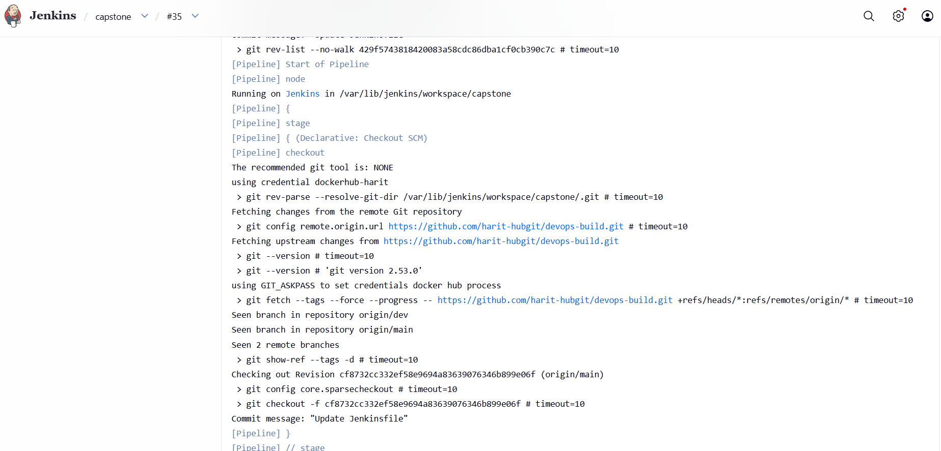
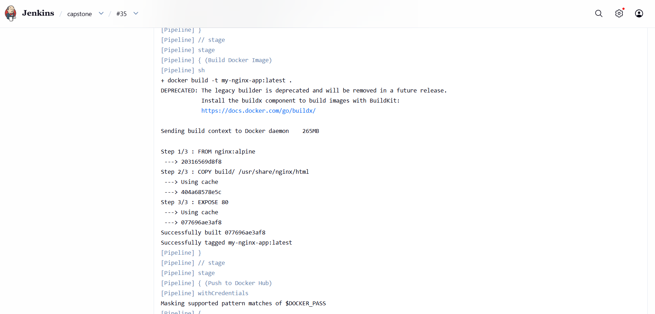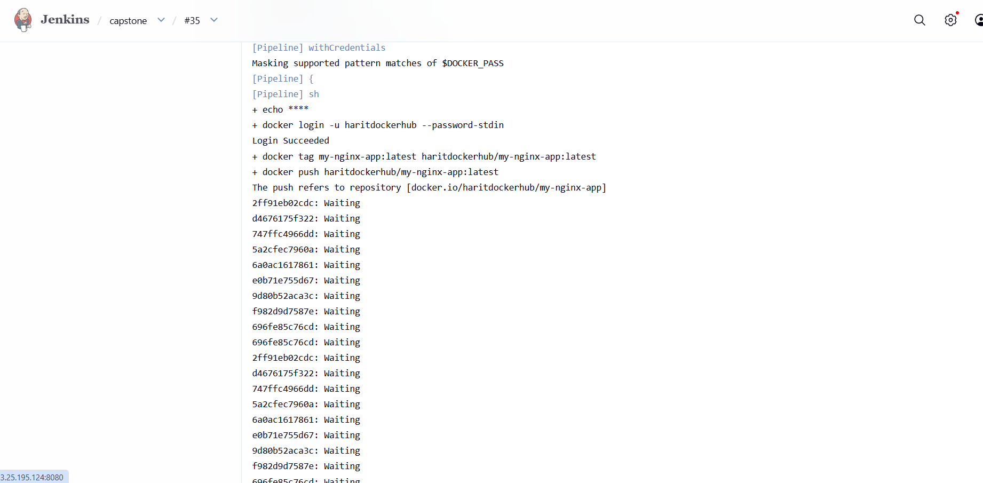
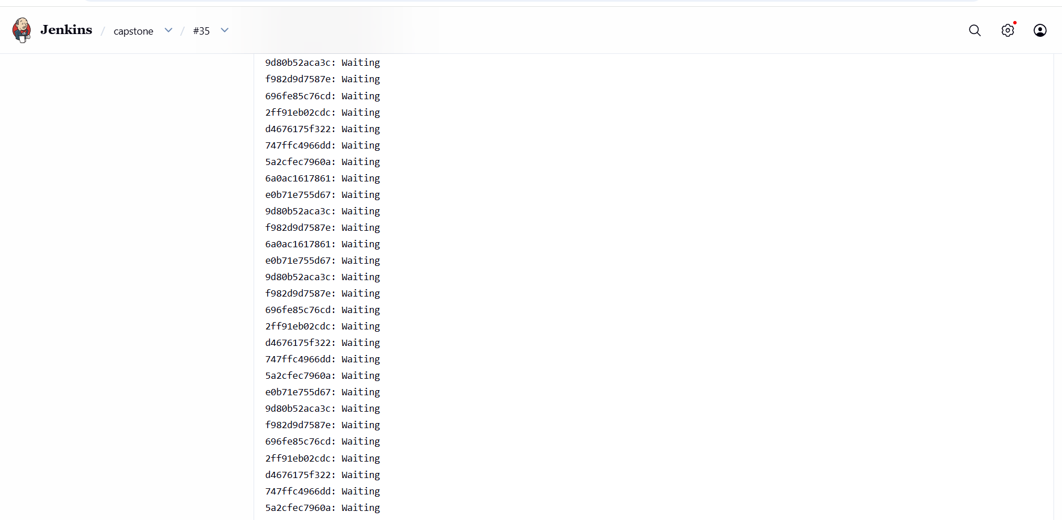
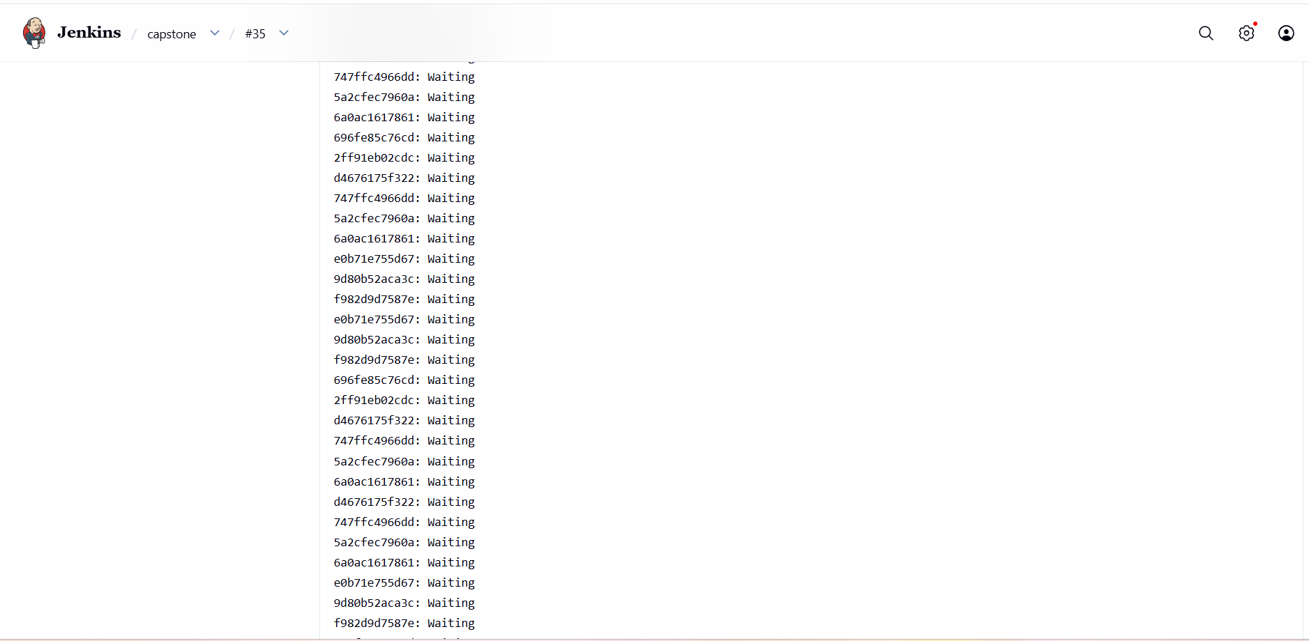
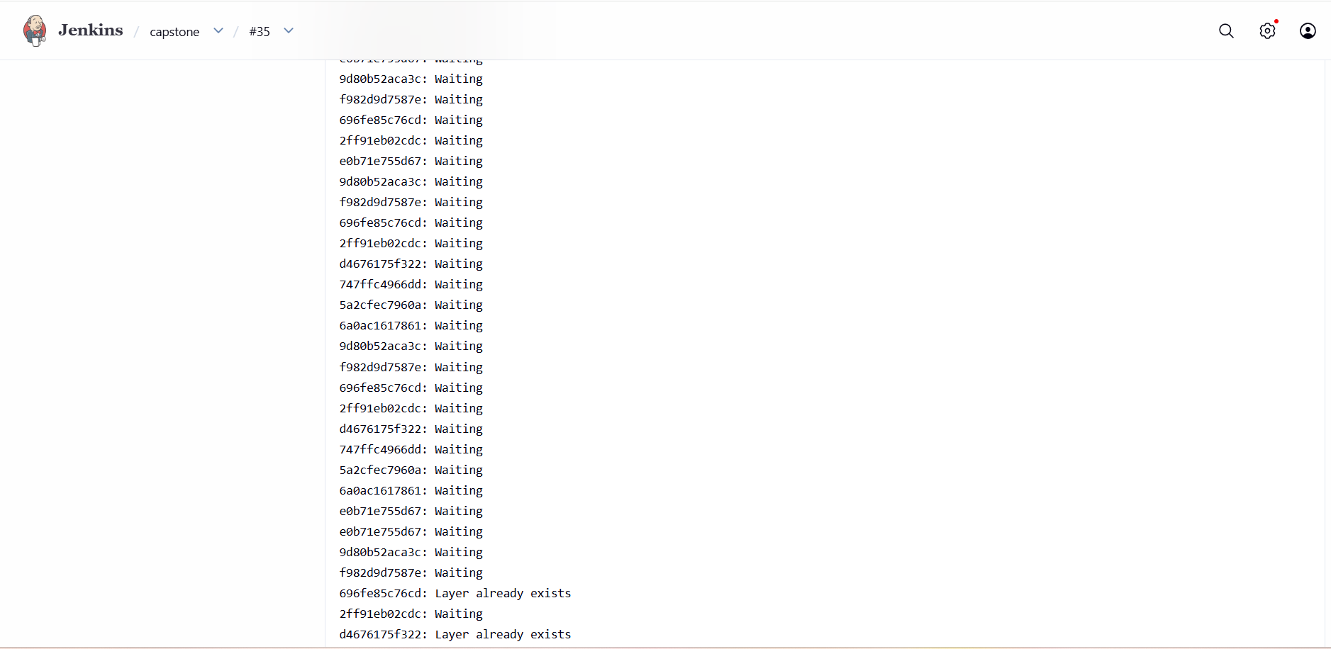
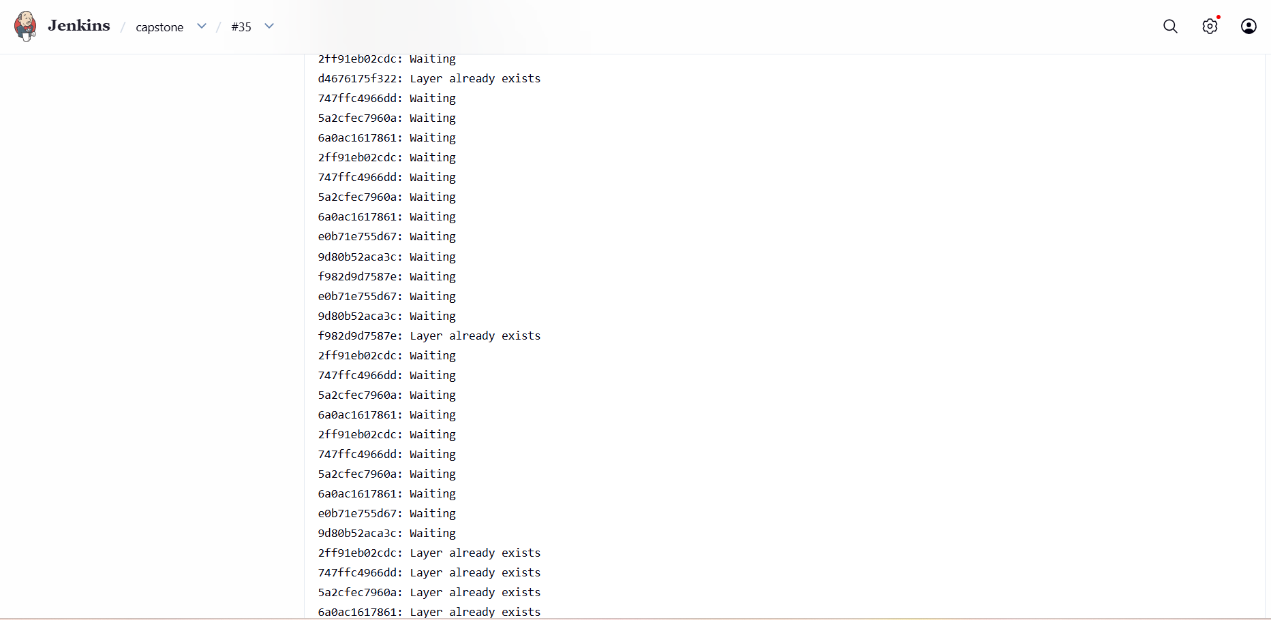
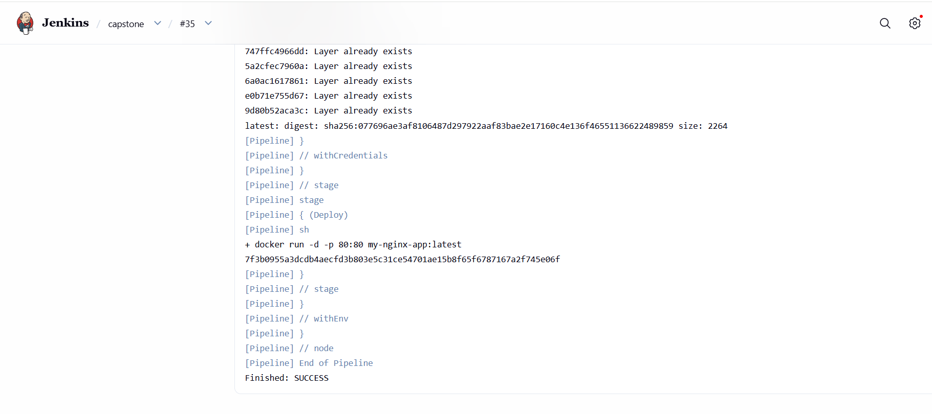

AWS
- Launch a t3.micro instance and deploy the created application
- Configure Security Groups (SG):
  - Anyone with the IP address can access the application
  - Server login should only be allowed from your IP address
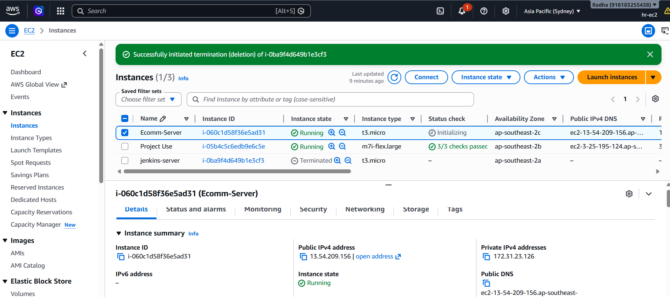
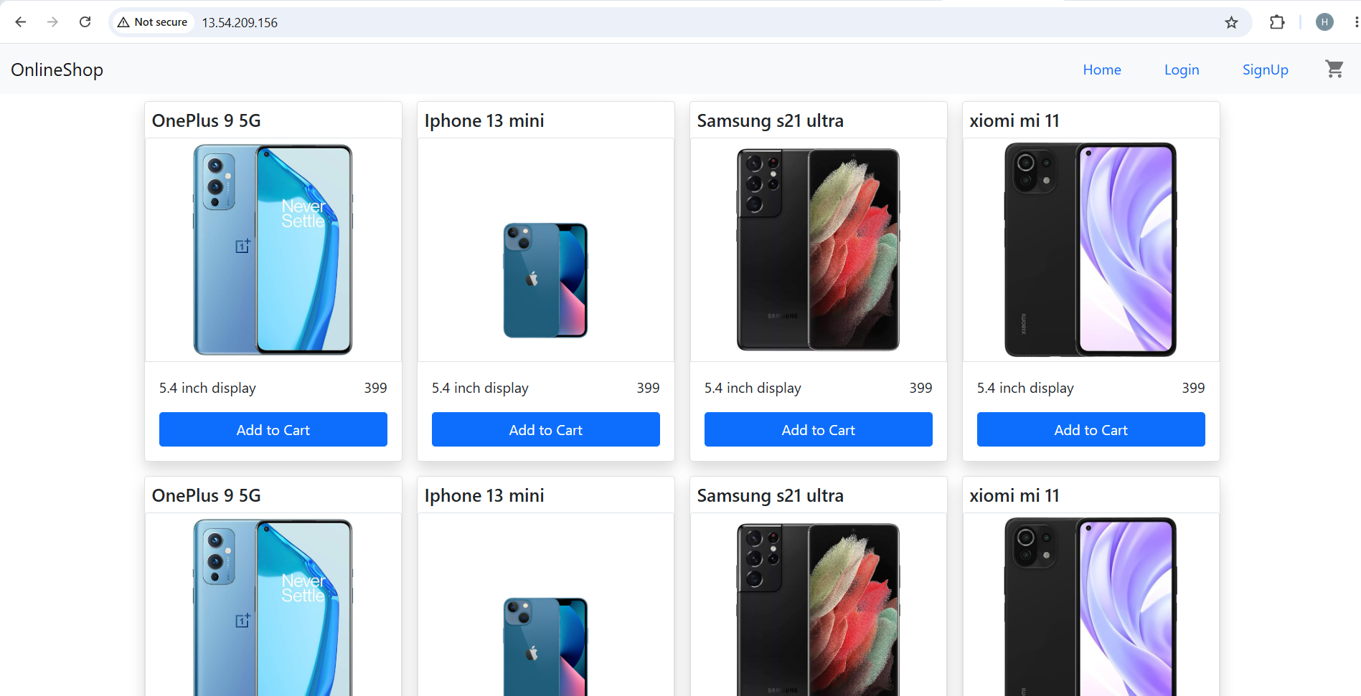
Monitoring
- Setup a monitoring system to check the health of the cluster or application (opensource) is highly appreciable.
- Sending notifications only if the application goes down is highly appreciable
